
ONLY FROM

HD / SD C Band Subscription Receiver
Rainier Satellite is proud to announce the New C Band HD Receiver designed for use on our C band subscription platform built by Cisco. This receiver has a built in integrated PowerVu decoder, and specifically set up for us to decode the subscription programming we are offering. It is built with the same high quality standards of all of Cisco's commercial products. Cisco Systems is a leader in broadcast and cable technology products, a name you can trust.

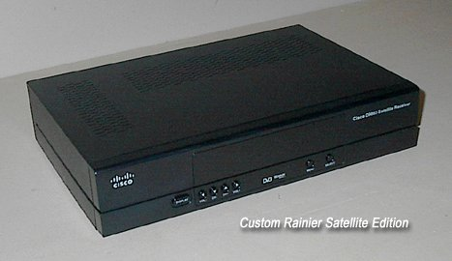

Facts and Information about the Receiver.
- It receives SD & HD Subscription PowerVu Programming.
- It has HDMI, Component, Composite, SPDIF, and RCA audio outputs.
- It receives all DVB S, S2, 8PSK, Mpeg 2 & 4 SD and HD channels.
- It receives FTA and Conditional Access Subscription channels.
- It is built by Cisco for us using Broadcast Commercial Quality Standards.
- It provides Extremely High Quality Video and Audio.
- It is a stand alone IRD that requires an external dish mover.
- Future add on accessories will be available for it.
- Currently we are testing the receiver with a select group.
- Currently we are testing subscription-programming channels.
- It will be available for your c band dish system from us in the near future.
Questions and Answers.
How will I move my dish and change polarity?
If you own a 4DTV you can use that. You can also use a good quality old analog receiver. If you need a mover and don't own a 4DTV or other receiver, a mover is being specially designed to work with the new receiver, it will also have other special features. Our dish mover will be coming out at a later date.
Where can I get the Receiver and Programming?
It will be available at Rainier Satellite (www.rainiersatellite.com)
Is this receiver made by Motorola or decode the Digicipher (DC-2) technology?
No, This is based on a different technology, Cisco PowerVu. Digicipher is a old dying technology and going away due to no support.
What about Subscription Programming?
Agreements are being made with programmers. Channel availability, lineup and packages will be provided prior to the rollout of the receiver to the general public.
How much will the receiver and programming cost?
Final receiver cost, pricing, and terms of use will be announced prior to rollout, stay tuned for updates. Programming costs will vary, depending on package chosen. Historically, C Band programming costs less than small dish or cable companies, that trend will continue.
When do you expect rollout?
Rollout of receivers and programming to the public is targeted for mid 2014. We are working hard to meet target date.
I currently have a subscription to the HITS X4 programming on the 4DTV, will I benefit from getting the new receiver and your programming?
There are three problems with the X4 HITS programming. (1) There is no HD. (2) The SD picture quality on remaining channels are suffering because of bitstarving due to their consolidation transition. (3) Comcast HITS has been removing channel access for C band subscription for years. This trend will continue.
The benefits with our receiver and programming are: We offer full HD and SD master feeds. This provides the best picture quality. We will continue to acquire more channels as time goes on. Wouldn't you rather see a high quality picture, and hear new channels are being added than taken away...
Will we get the first generation broadcast master feeds?
Yes, This is what we are working on with programmers. There seems to be some confusion with the Comcast HITS upgrade plans for their services delivered to cable companies. HITS is not involved or will be used for this. The channels available from us will be direct to home from the programmer’s national master source.
Will my current dish work?
As long as you have a well-tuned movable dish, 8 foot or larger, in good parabolic condition, using a good high quality LNB (a PLL may be needed for some muxes) you should be fine. Since modulation is DVB S2 8PSK, smaller dishes or borderline systems may have issues receiving a 100% reliable signal. Broadcast signals are targeted at 3.8 to 5 meter (12 to 16ft) dishes at headends. This is why your system needs to be up to the task to receive these gems. If it's not you will need to upgrade.
How is the picture quality?
The picture quality is breathtaking to say the least The detail is sharp and clear, the colors are true and very accurate. It can only be compared to by professional headend gear used at TV stations, costing many thousand of dollars. This unit is broadcast quality nothing less.
Will this receiver receive KU band?
Yes, It will work with a DiSEqC switch.
How big is the receiver?
Its approximately 12" x 8" x 3".
How many pay channels will there be?
We are working on getting a variety of popular subscription channels. Some will be C band only exclusives. 90% or more will be in HD. Programming packages and pricing will be provided with the rollout of the receiver for purchase to the general public.
I currently have DirecTV, Dish Network, IPTV or Cable for HD, will I see a difference in picture quality?
YES! C band master HD rivals or is better than Blu-ray quality. Think about how good that will look on a 60-inch screen. The time has come for quality to be offered to the consumer again.
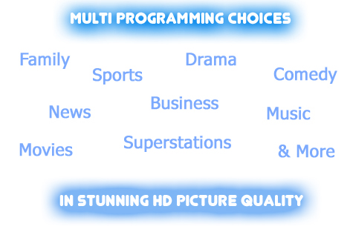
Our Mission Statement
Our mission is to provide our clients with the highest quality of customer service, by committing ourselves to be the best through continuous improvement. We are dedicated to delivering an exceptional experience for every client. We pledge to make a difference for our clients by focusing on integrity, respect and loyalty.
Rainier Satellite is a Member of:
  FCC Licensed
© Copyright Rainier Satellite LLC 2014, All Rights Reserved.
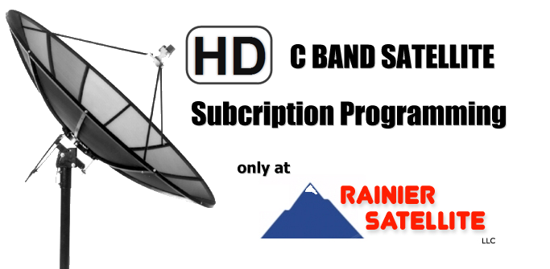
Channel List Coming Soon…
This facts sheet will be updated in the near future.

